SIMATS ENGINEERING
ASSESSMENT TOOL 2

COURSE NAME: Ethical Hacking COURSE CODE: ITA14

COURSE OUTCOME COVERED

CO2: Execute footprinting in social engineering such as DNS analysis, competitive intelligence gathering, and attack simulations to collect relevant information for identifying potential security risks.

Assessment Tool Weightage: 30%

Duration: 90 min Total Marks: 50

Social Engineering Simulation

Questions

- As a Security Analyst, perform an OSINT-based email enumeration assessment on the target domain tesla.com using theHarvester in Kali Linux. Collect publicly available email addresses, subdomains, hosts, and IP addresses associated with the organization. Categorize the discovered email addresses into likely roles such as Support, Sales, Human Resources, Administration, and Technical Teams. Analyze how the gathered information could assist an attacker during the reconnaissance phase and explain how it could be used for spear-phishing, credential harvesting, and impersonation attacks. Finally, recommend at least five countermeasures to reduce information leakage and social engineering risks, and submit a report with screenshots, commands executed, findings, risk analysis, and recommendations. (20 Marks)

- As a cybersecurity awareness consultant, you are required to conduct a phishing awareness simulation using GoPhish and dummy employee accounts provided in the lab. Create an email template, launch a campaign, monitor user interactions, and generate a report showing delivery rate, email open rate, and click rate. Based on the results, provide recommendations to improve user awareness against phishing attacks.(20 Mark).

- Using Nmap Aggressive Scan (-A) on scanme.nmap.org, gather detailed information about the target including operating system details, open ports, and service versions. Assume you are an attacker and describe how the collected information could be leveraged to conduct a social engineering attack against the IT support team. Prepare a report explaining the attack methodology and defensive recommendations.(10 Marks)

Code of Conduct:

I M.Supraja(192472301) (Name / Reg No) certify that this submission is my original work and that I have adhered to the guidelines specified for this assessment.
I understand that any violation of academic integrity rules will result in disciplinary action.

Signature of the student: M.Supraja

Question 1: OSINT Email Enumeration Assessment using theHarvester
Objective
To gather publicly available information related to tesla.com using theHarvester and analyze how attackers could use the information during reconnaissance.
Tool Used
• Kali Linux
• theHarvester
Commands Executed
theHarvester -d tesla.com -b crtsh theHarvester -d tesla.com -b yahoo theHarvester -d tesla.com -b subdomaincenter
Screenshots
Insert screenshots of:
- theHarvester execution

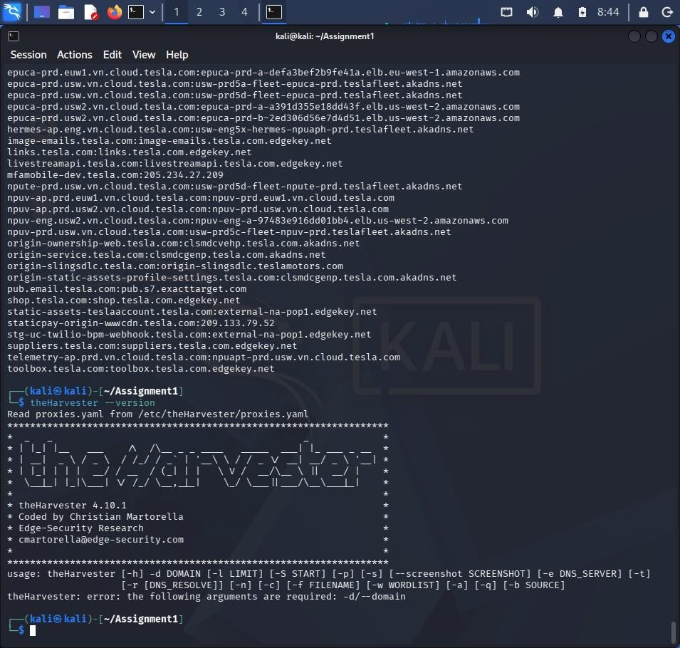

- Subdomains discovered

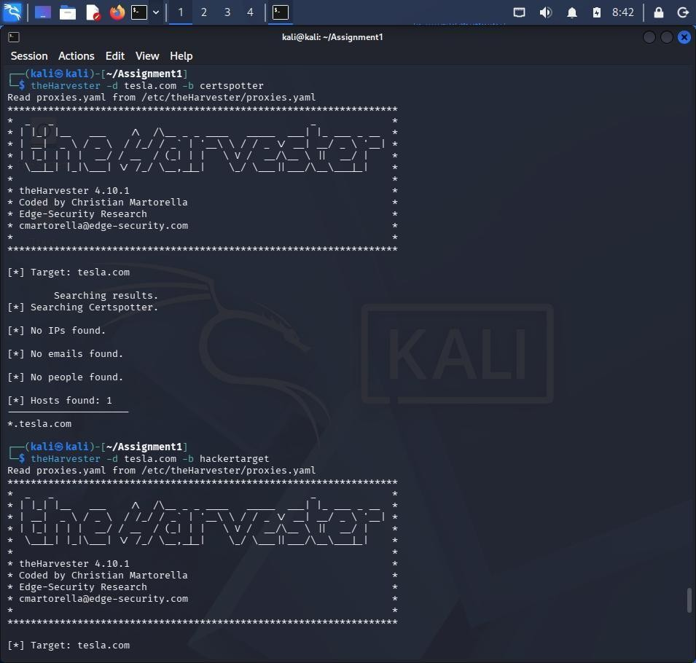

- Hosts/IPs discovered

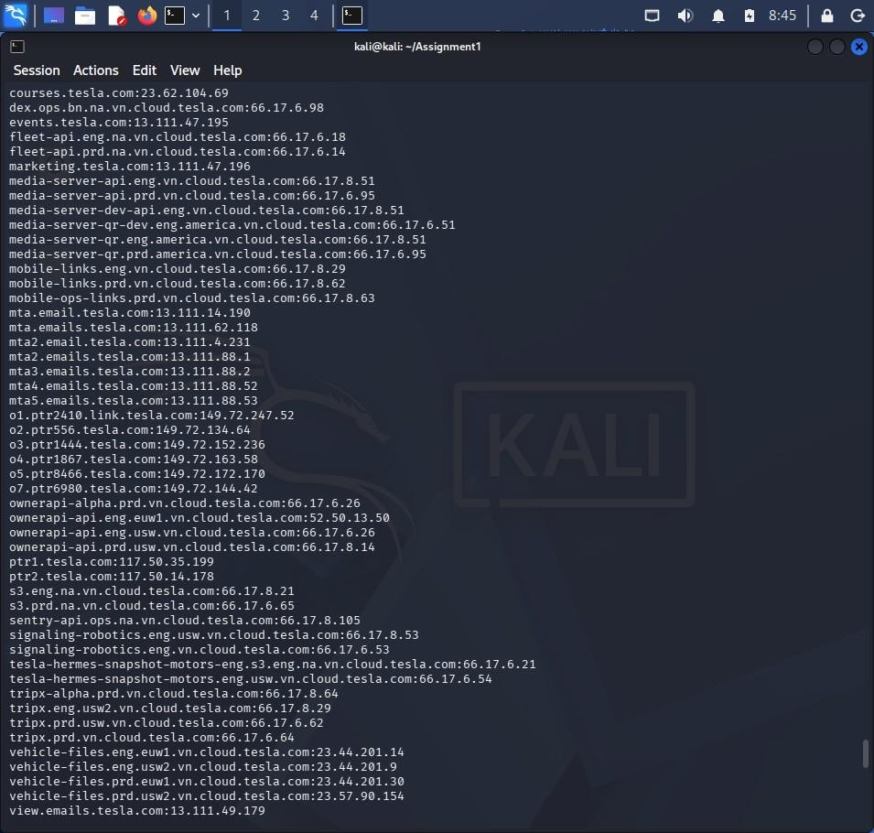

Findings
Subdomains
Create a table using the results you obtained.

Subdomain | IP Address
mta.email.tesla.com | 13.x.x.x
view.email.tesla.com | 13.x.x.x
ptr1.tesla.com | 117.x.x.x
(Add more from your results.)
Email Addresses
If no emails were found:
No public email addresses were discovered during enumeration.
Hosts and IP Addresses
Include the hostnames and IPs you collected.
Categorization of Email Roles
Example:

Role | Example Email
Support | support@company.com
Sales | sales@company.com
HR | hr@company.com
Administration | admin@company.com
Technical Team | tech@company.com
If none were found, write:
No email addresses were discovered; therefore role categorization could not be performed.

Risk Analysis
Spear-Phishing
Attackers can use discovered domains and hostnames to create convincing phishing emails.
Credential Harvesting
Fake login portals can be created using discovered organizational information.
Impersonation Attacks
Attackers may impersonate internal departments.
Countermeasures
- Limit public exposure of employee email addresses.
- Use privacy protection for DNS records.
- Conduct security awareness training.
- Implement SPF, DKIM, and DMARC.
- Use Multi-Factor Authentication (MFA).
- Monitor information leakage.
Conclusion
OSINT can reveal valuable organizational information that attackers can leverage during reconnaissance.

Question 2: Phishing Awareness Simulation using GoPhish
Objective
To simulate a phishing campaign and measure user awareness.
Tool Used
- GoPhish
- Kali Linux
Campaign Setup
User Group
Dummy Employees

Name | Email
John Doe | john@testlab.local
Jane Smith | jane@testlab.local
David Kumar | david@testlab.local
Sarah Lee | sarah@testlab.local
Email Template
Subject:
Action Required: Password Reset
Landing Page
Password Reset Portal
Screenshots
Insert screenshots of:
- GoPhish Dashboard
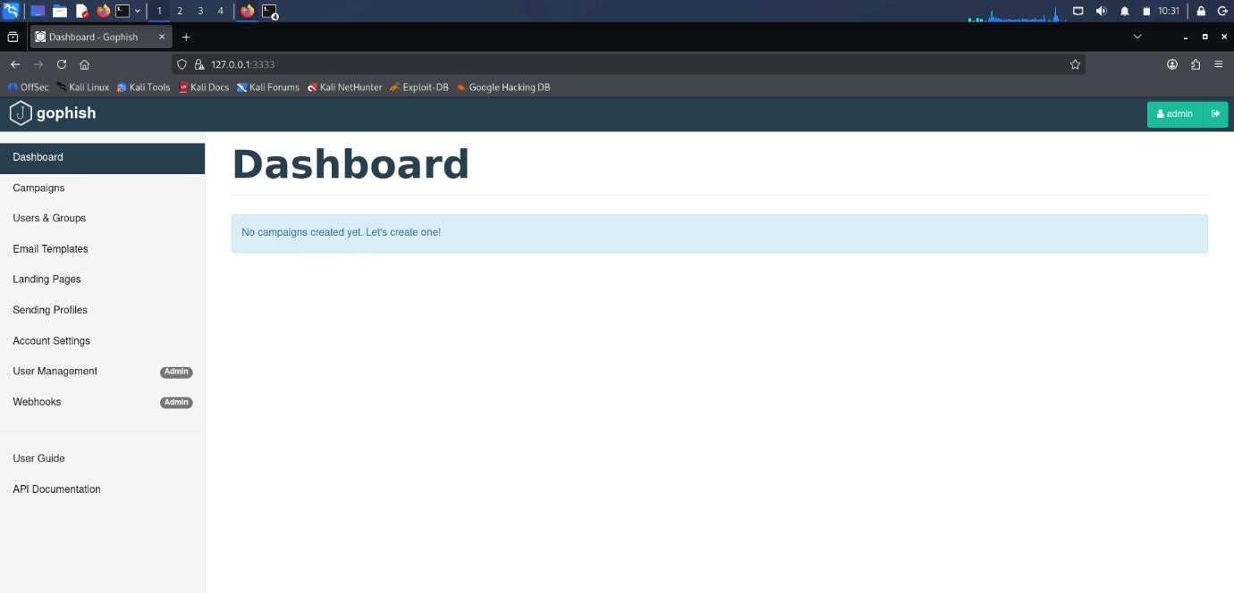

2.User Group Creation

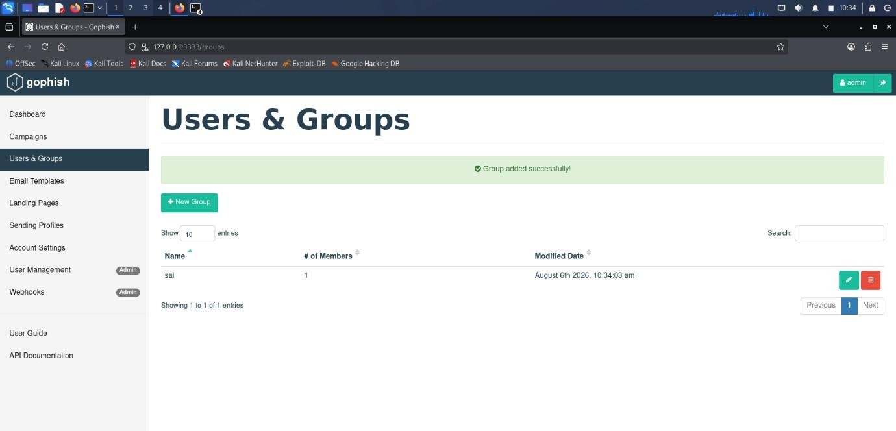

3.Email Template Creation
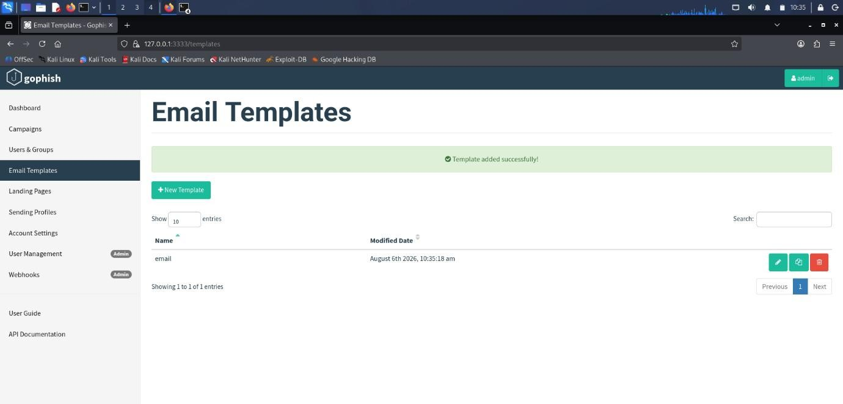

- Landing Page Creation

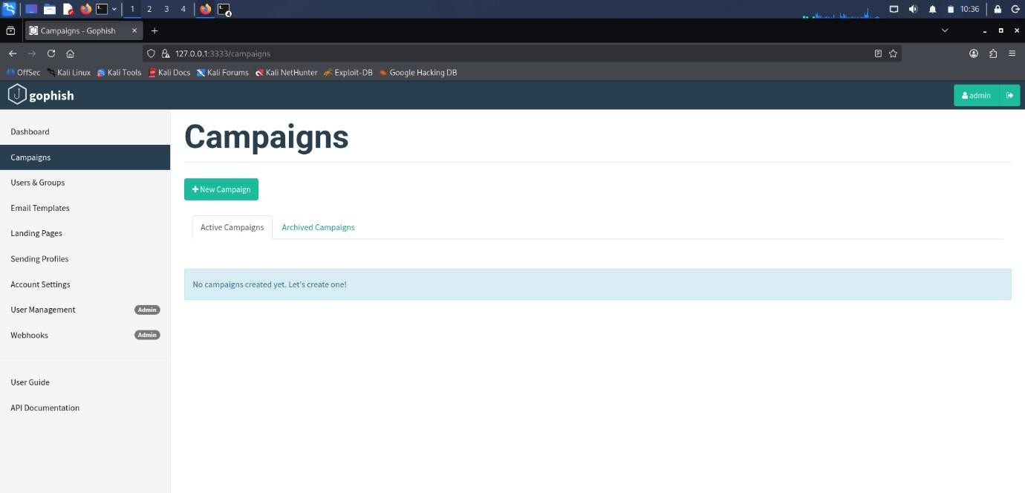

Campaign Results
Use the values shown in your dashboard.
Campaign Results Table

Metric | Value
Total Emails Sent | 4
Successfully Delivered | 4
Emails Opened | 3
Links Clicked | 2
Credentials Submitted | 1
Delivery Rate
Formula:
(Delivered / Sent) × 100
Open Rate
(Opened / Sent) × 100 Click Rate
(Clicked / Sent) × 100
Recommendations
- Conduct regular phishing awareness training.
- Verify sender identities.
- Enable MFA.
- Avoid clicking unknown links.
- Report suspicious emails immediately.
- Deploy email security controls.
Conclusion
The phishing simulation highlighted user susceptibility to phishing attacks and the need for ongoing awareness programs.

Question 3: Nmap Aggressive Scan Assessment
Objective
To gather information about scanme.nmap.org using Nmap Aggressive Scan and analyze social engineering risks.
Tool Used
- Nmap
- Kali Linux Command Executed
nmap -A scanme.nmap.org
Findings
Open Ports
Port | Service
22 | SSH
80 | HTTP
9929 | NPING Echo
31337 | Elite

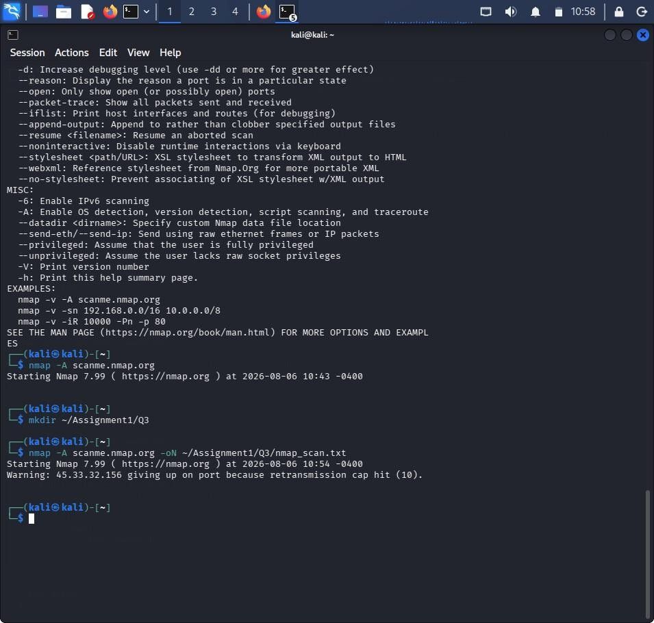
Service Versions
List detected versions from your scan.
Operating System
Linux-based operating system (or whatever Nmap reported).
Attack Methodology
Reconnaissance
Gather service and OS information.
Social Engineering
Create phishing emails pretending to be IT Support.
Example Subject:
Critical SSH Service Upgrade Required
Objective
Steal administrator credentials through a fake login page.
Defensive Recommendations
- Minimize service banner exposure.
- Apply security patches regularly.
- Enable MFA.
- Restrict administrative access.
- Conduct awareness training.
- Monitor suspicious activity.
Conclusion
Nmap revealed system information that could help attackers craft targeted social engineering attacks.

RUBRICS FOR CALCULATION

Social Engineering Simulation
Criteria | Weightage (%) | Level 4 (Exemplary) | Level 3 (Proficient) | Level 2 (Developing) | Level 1 (Beginning)
Understanding of Social Engineering Scenario | 20% | Demonstrates a comprehensive understanding of the social engineering scenario, attack techniques, and security context | Demonstrates good understanding with minor omissions. | Shows partial understanding but misses important aspects of the scenario. | Fails to understand or incorrectly interprets the social engineering scenario.
Identification of Attack and Vulnerabilities | 20% | Correctly identifies the attack type, exploited vulnerabilities, and affected assets with complete accuracy | Correctly identifies most attack techniques with minor errors. | Identifies only some attack methods and vulnerabilities. | Unable to identify the attack type or associated vulnerabilities.
Application of Security Concepts and Countermeasures | 25% | Effectively applies cybersecurity concepts and recommends appropriate preventive, detective, and corrective countermeasures. | Applies relevant concepts with minor errors and recommends suitable countermeasures. | Applies concepts partially with limited recommendations. | Unable to apply relevant cybersecurity concepts or recommend suitable countermeasures.
Risk Analysis and Decision Making | 20% | Performs logical risk analysis, evaluates business impact, and provides well-justified security decisions. | Provides reasonable analysis with adequate justification. | Performs limited analysis with weak justification. | Provides no meaningful analysis or justification.
Clarity, Documentation and Technical Presentation | 15% | Response is well-organized, technically accurate, professionally documented, and logically presented. | Response is clear with minor documentation or presentation issues. | Response lacks organization and contains technical inaccuracies. | Response is poorly organized, incomplete, and difficult to understand.

